**11th May 2016**

**Yokohama Tire Manufacturing Virginia, LLC Wins Environmental Awards**

The Salem plant is honoured for its zero landfill achievement and outstanding compliance record

SANTA ANA, CA - Yokohama Tire Manufacturing Virginia, LLC (YTMV) has received two awards for outstanding achievements in sustainable manufacturing: the Environmental Excellence Gold Award from the Virginia Water Environment Association and the bronze Governor’s Environmental Excellence Award.

The Environmental Excellence Gold Award recognizes YTMV for its demonstrated commitment to pollution prevention and elimination or reduction in waste, maintaining continued perfect compliance with industrial waste water and pre-treatment standards.

The Governor’s Environmental Excellence Award, presented during the 27th Annual Environment Virginia Symposium in Lexington, VA, recognizes the zero landfill operation project completed by YTMV in 2015. The award honours conservation leaders who have made significant contributions in four categories: sustainability, environmental project, land conservation and implementation of the Virginia Outdoors Plan.

“We are proud of all our sustainability efforts and achievements at our Salem, Virginia plant,” said Neil Dalton, Director of Environmental Health and Safety at Yokohama Corporation of North America. “We look forward to continuing the success of our initiatives at YTMV.”

The facility began implementing changes in 2013 and in just two years, it had reduced the landfill waste output from all waste generated to two percent and finally to zero by September 2015.

The awards reinforce the ongoing global environmental commitment from The Yokohama Rubber Co., Ltd. (YRC), YTMV’s parent company in Japan. It stems from YRC’s ‘Grand Design 100’ Plan (GD100), which sets standards for YOKOHAMA to harmonize its company-wide operations in everything from manufacturing to product design with the environment.

Yokohama Tire Corporation (YTC) and Yokohama Tire Manufacturing Virginia, LLC (YTMV) are part of Yokohama Corporation of North America (YCNA), a wholly-owned subsidiary of Tokyo, Japan-based The Yokohama Rubber Co., Ltd. (YRC), a global manufacturing and sales company of premium tyres since 1917. YCNA oversees all YOKOHAMA-related operations in North America, including sales and marketing, manufacturing, technical development, long-term corporate planning and investment. YTC services an extensive sales network throughout the U.S., and is a leader in technology and innovation. The company’s complete product line includes tyres for high-performance, light truck, passenger car, commercial truck and bus, and off-the-road mining and construction applications.

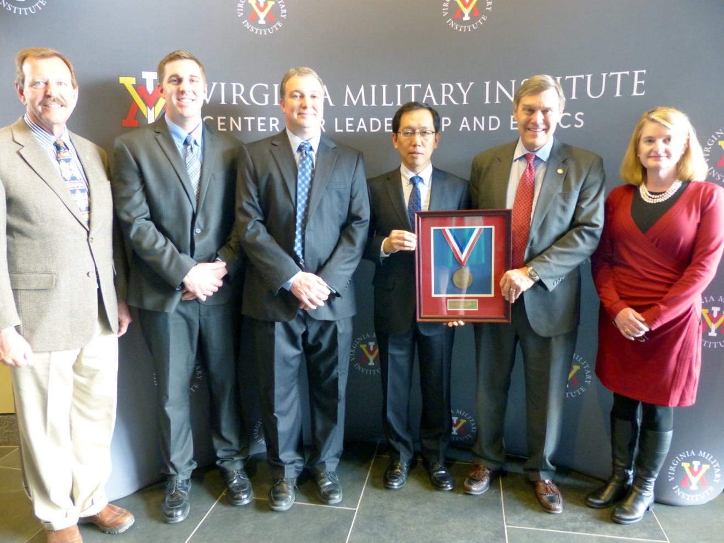*YTMV accepts the Governor’s Environmental Excellence Award. L-R: Clyde Cristman, VA Dept. of Conservation and Recreation; Christian Yates, YTMV; Neil Dalton, YTMV; Tetsuro Murakami, YTMV;  David Paylor, VA Dept. of Environmental Quality; Molly Ward, VA Secretary of Natural Resources.*